- Creating and Renaming Files/Directories

Cmd:- mkdir <directory_name>, touch, rm
- Used this cmd to create test_dir
- Used rm touch cmd to create empty file named- example.txt
- Used rm cmd to rename existing file to renamed_example.txt

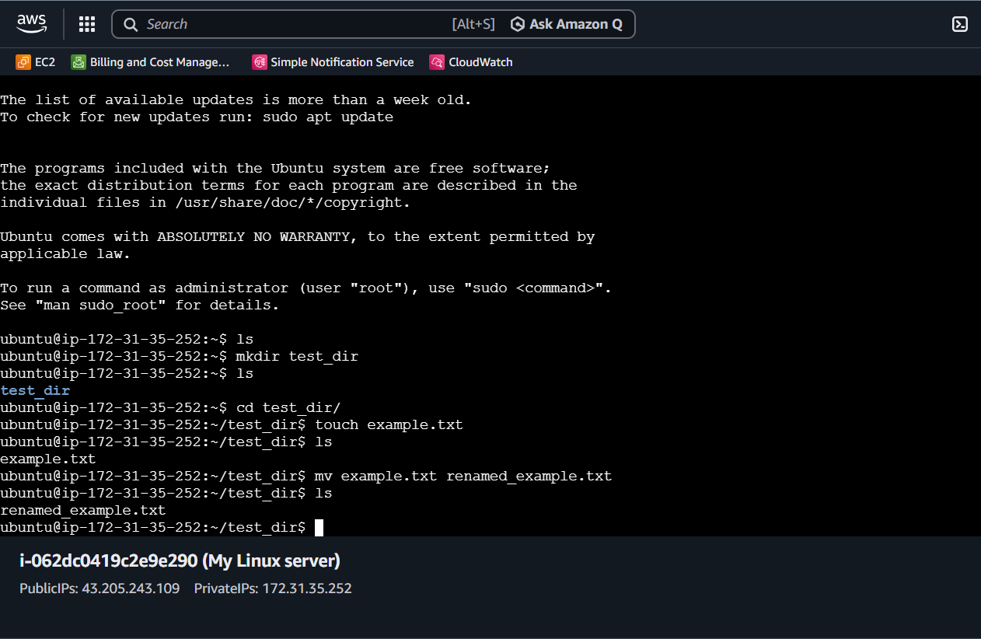

- Viewing File Contents

Cmd :- cd ../.. , cat, head, tail

Navigate to home using cd ../.. and then at loc. /etc
Open the content of passwd file using “cat passwd” cmd
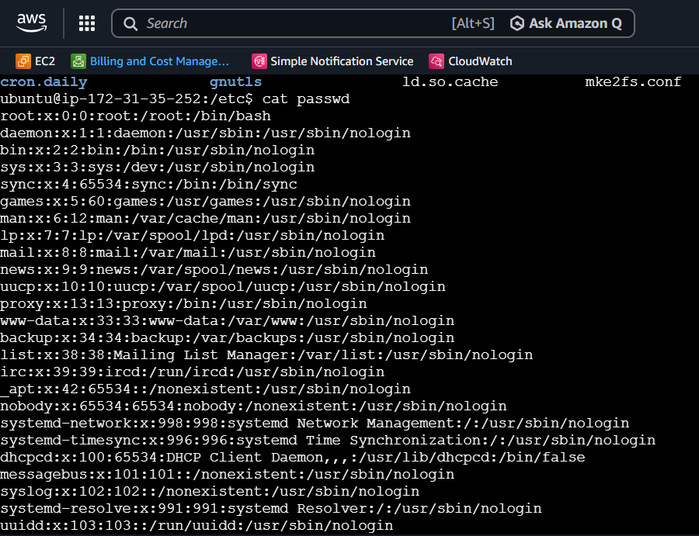

Here using “head -n 5 passwd” cmd fetch first 5 lines of passwd file
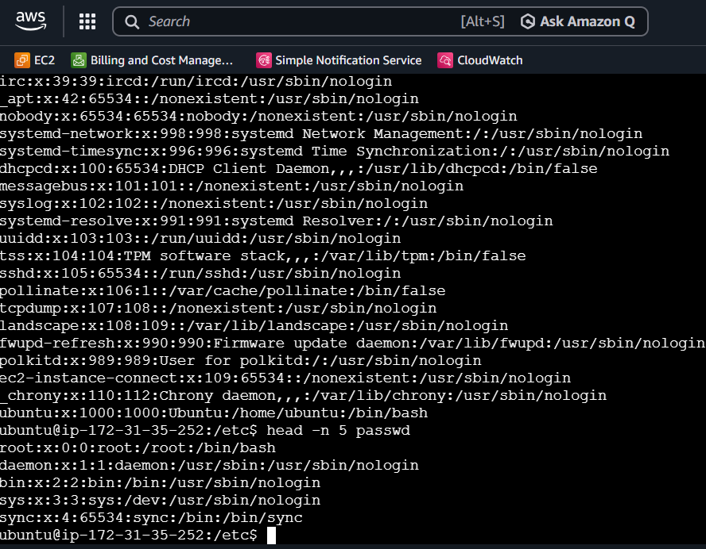
Here using “tail -n 5 passwd” cmd fetch last 5 lines of passwd file

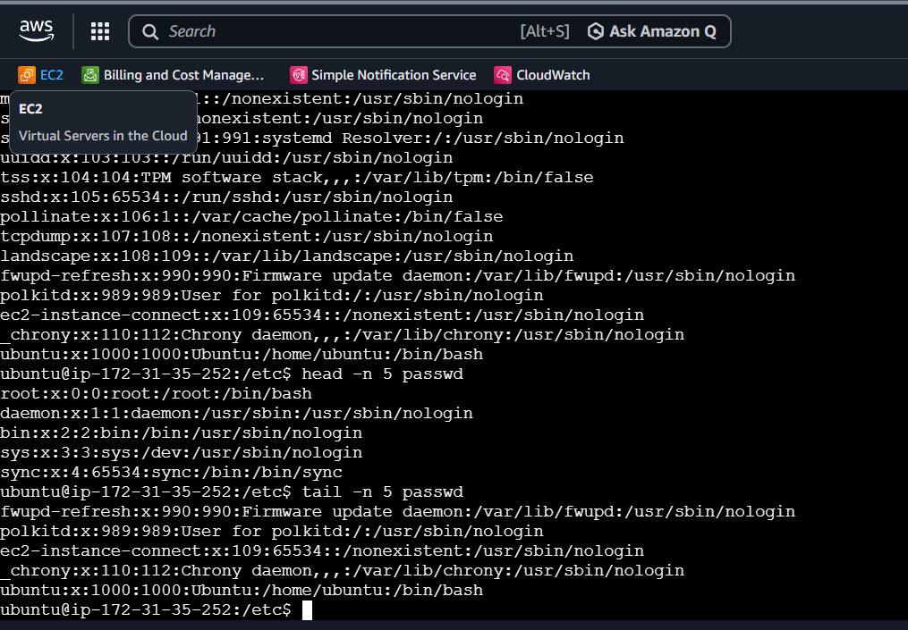

- Searching for Pattern
Here used “cat passwd | grep root” cmd to display word root in passwd file
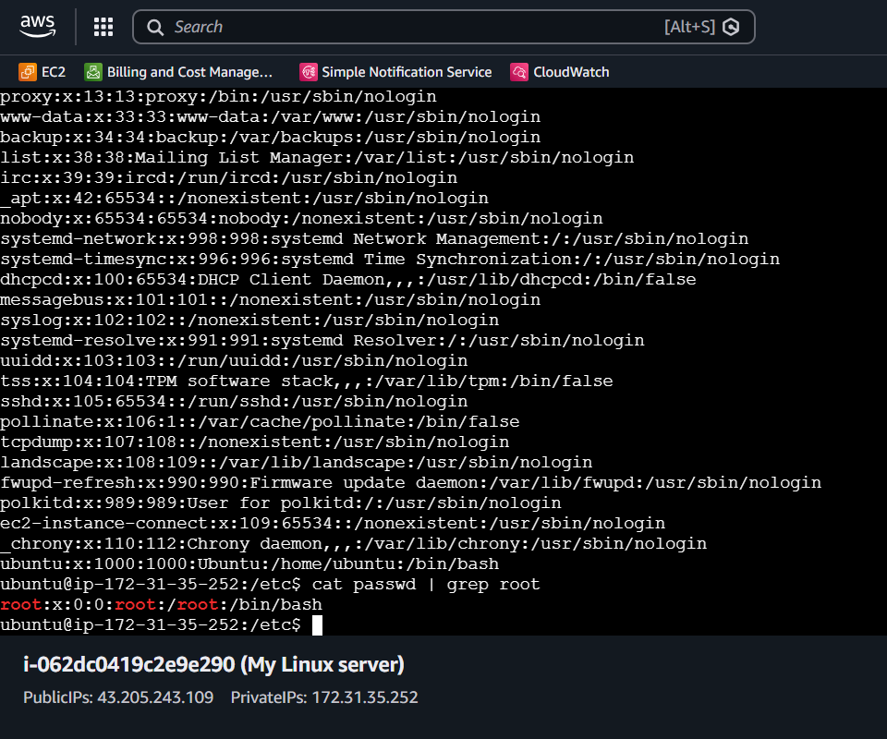

- Zipping and Unzipping
Here installed zip and unzip package using “sudo apt install zip unzip” cmd

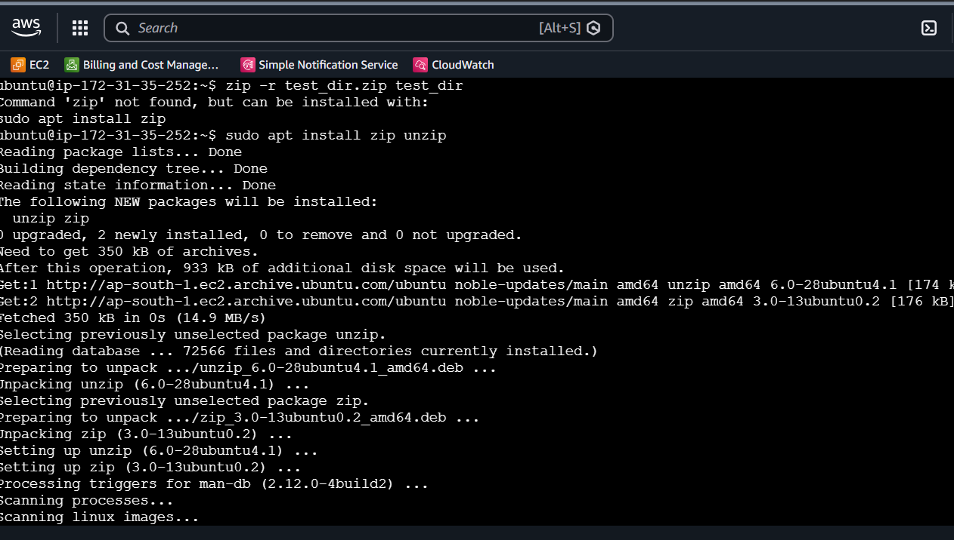

Then zipped test_dir direcorty to test_dir.zip file
For Unzip
Create unzipped_dir using mkdir cmd and then used “unzip test_dir.zip -d unzipped_dir” cmd to unzip content to unzipped_dir directory

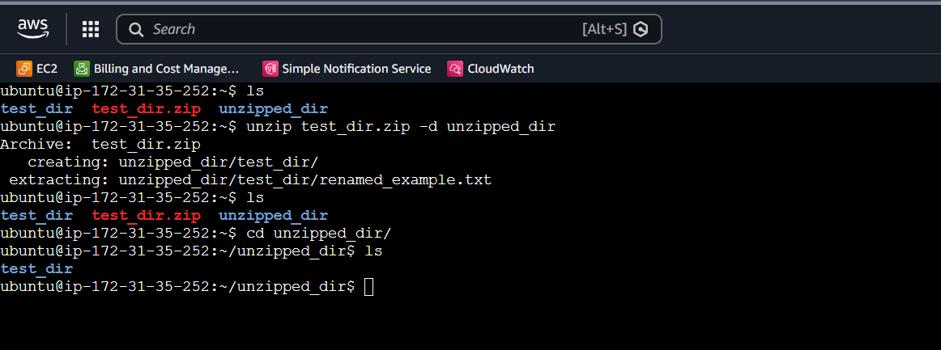
- Downloading files
Used wget “URL” cmd to download data
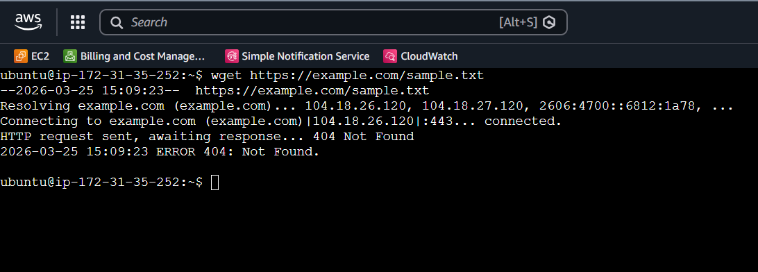
- changing permission
create secure.txt file using “touch secure.txt” cmd and then changed permission using “chmod 444 secure.txt” cmd
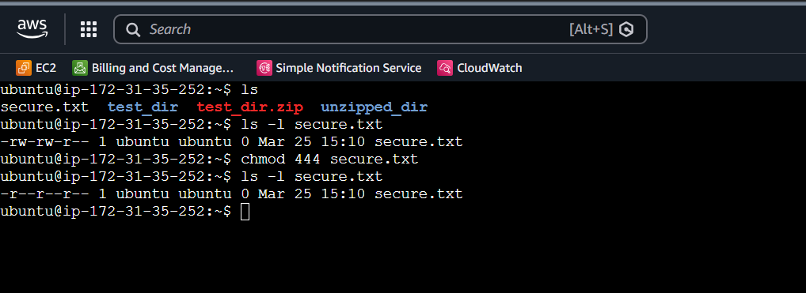

- Working with Environment variable
Here used export cmd to set env variable MY_VAR with value Hello Linux
Cmd – export MY_VAR= “Hello, Linux!”
Echo $MY_VAR

